**First research poster competition for medical students and faculty members**

**Mekran Medical College, Turbat, Balochistan**

**Dr. A. Waheed Buledi**

**Demonstrator and Vice Principal**

**Department of Physiology**

**Mekran Medical College, Turbat, Balochistan**

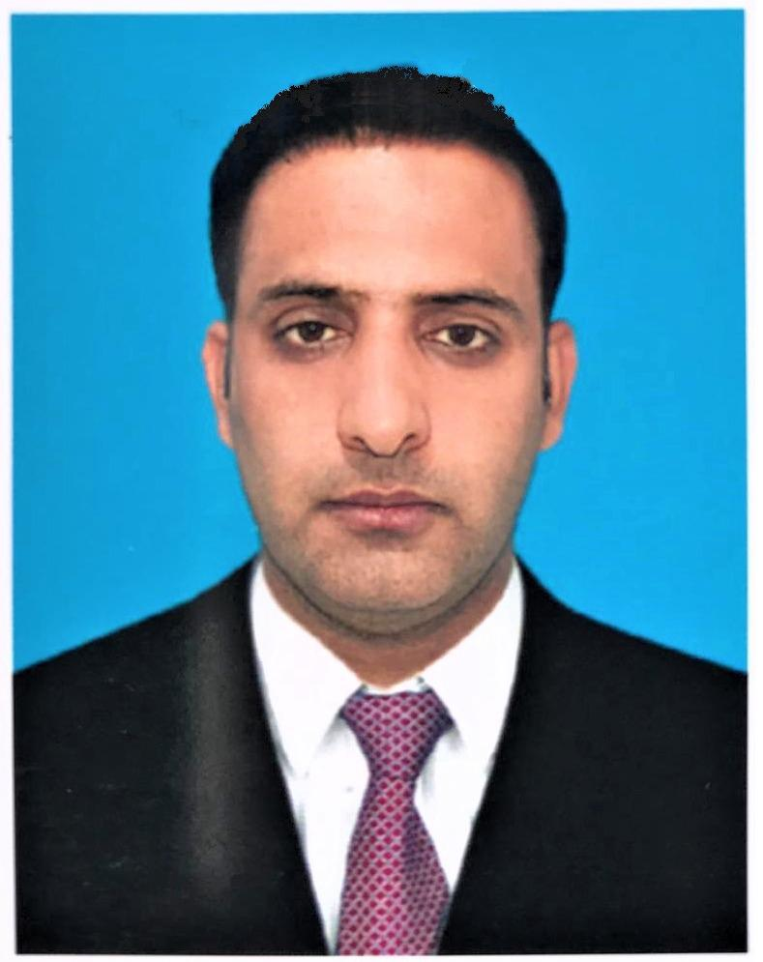

**Dr. Santosh Kumar Sidhwani**

**Associate Professor**

**Department of Pathology**

**Mekran Medical College, Turbat, Balochistan**

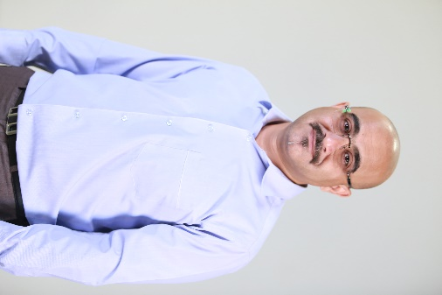

First Research poster competition was successfully held on 8th November, 2023 at newly constructed Gymnasium Mekran Medical College (MMC), Turbat, Balochistan. This mind-blowing healthy competition was organized by the Department of Pathology, MMC, Turbat with the collaboration of Pakistan Physiological Society and [SAAP] South Asian association of physiology with the efforts of worthy Principal, Dr. Muhammad Afzal Khaliq, Head of Pathology, Professor Dr. Sanaullah Gazozai, Associate Professor of Pathology, Dr. Santosh Kumar Sidhwani and counselor Pakistan Physiological Society Balochistan chapter and Vice principal MMC, Dr. A. Waheed Buledi. All the students and various faculty members participated in the competition. Total 19 research posters were presented, included from the various disciplines of the college and hospital. The purpose of this event was to promote the research abilities of Faculty and students in order to create a research climate in college.

The program was started with the recitation of Holy Quran followed by the welcome of chief guest (Principal MMC, Dr. Muhammad Afzal Khalid) and the respected judges (Dr. Misbah Muneer, Medical Director, Teaching hospital Kech, Turbat: Dr. Hani-U-Rehman, Associate Professor, University of Turbat: Dr. A. Waheed Buledi, Vice Principal MMC, Turbat). Welcome word was given by the Chief organizer Head of Pathology Dr. Sanaullah Gazozai who introduced the judges to the students and faculty members. Principal MMC also expressed his views about this competition and urged to continue these types of events in future to make the students and faculty research oriented and to keep them updated with the world of research.

The senior faculty members praised the event as it was organized for the first time in the MMC, Turbat that not only provoked the students to do the researches but also introduced them to the basics of research like types studies and analysis performed during the researches. Students were so excited for the research studies they performed and intended to continue these activities during the academics. Honorable judges evaluated the all aspects of posters included with the organizing committee and cross communicated with the competitors. During the event students from 1st, 2nd, 3rd and 4th year also admired the event and gave their insights that these types of competitions are necessary to open the mind, to think about causes, to find some hidden truths, and reasoning involved in the various pathologies and diseases. They said that they were not aware about the bits of research before but after this event they at least know the basics.

After the evaluation judges announced the winners where poster number 13 entitled “**Barriers between the physician and patient relationship**” presented by the 3rd year student got the 1st prize. Three of the students also got the shields and cash prizes who had the outstanding performance throughout the academic career and are toppers in their respective classes named Gul Makai, Tanisha Kumari, Yousaf khan, and Zahida. At the end of the event Dr. Santosh Kumar Sidhwani (Organizing committee) promised the students to continue these events in the future.

Students preparing for careers in the sciences benefit from learning to communicate scientific information. Poster competitions give students the ability to practice written and oral communications skills. Hosting poster competitions is one way that can effectively sustain their role as a learning environment focused on good scientific communication. Exercising its strength as a central and neutral place on colleges and universities. Often poster sessions are the first way many undergraduate and graduate students make to engage with colleagues, mentors in their disciplines, thus increasing self-confidence and developing their own academic voice. On the other hand, these events have encouraged participants to explain their research to a broader, non-specialist audience and foster communication of new research, all the while increasing their own understanding of the subject discussed in the poster. Some academic institutions have implemented practice poster competitions with cash prizes that skillfully mimic the atmosphere of a bona fide scientific conference to ease the pressure of presenting for the first time.

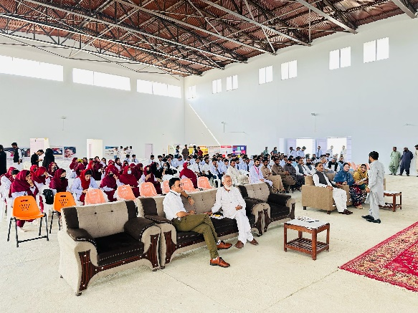 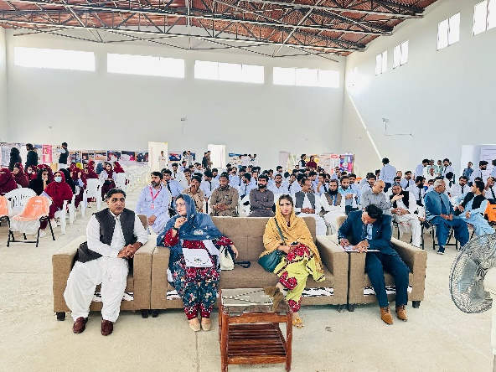

Pictures of the events (Students and Faculty members)

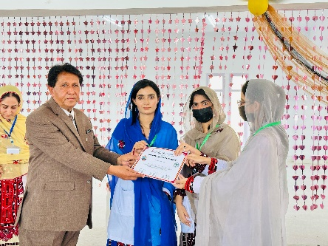 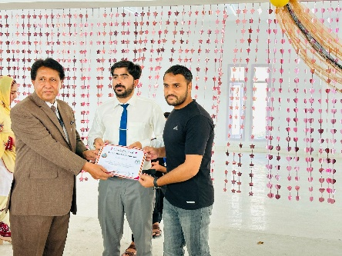 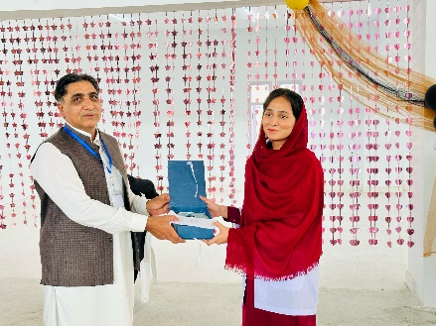

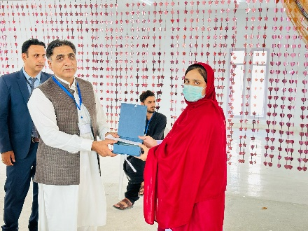 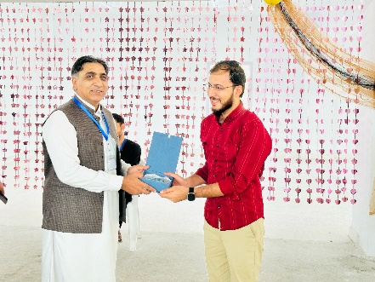 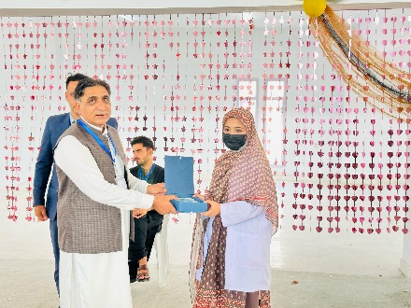

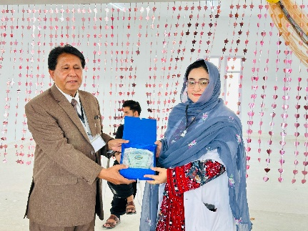 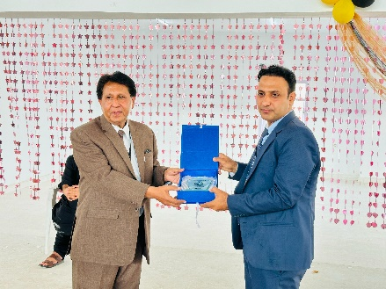 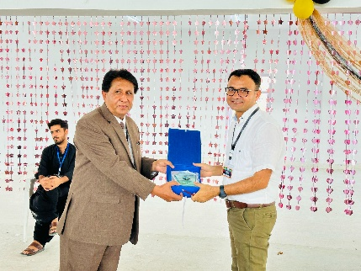

Distribution of shields and cash prizes to students and shields to respected judges

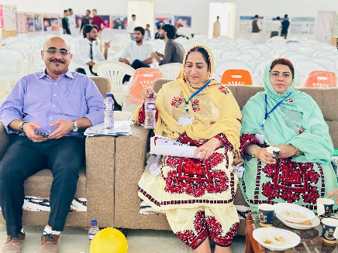 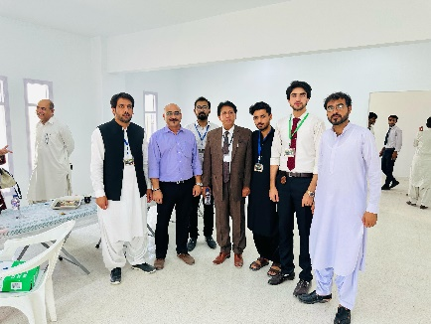 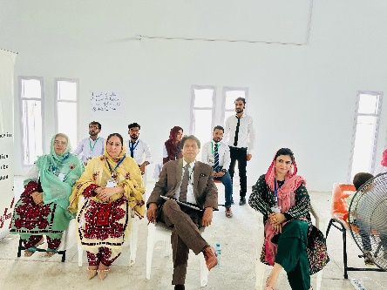

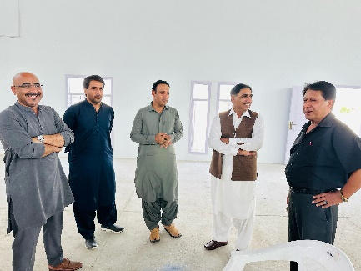 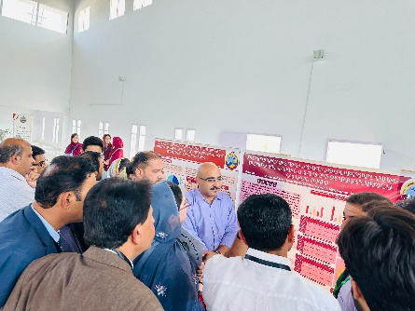 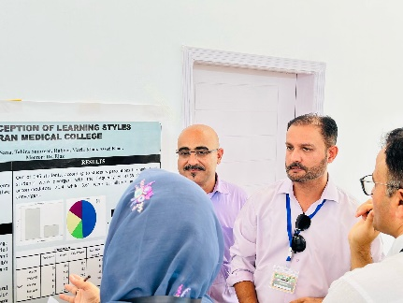

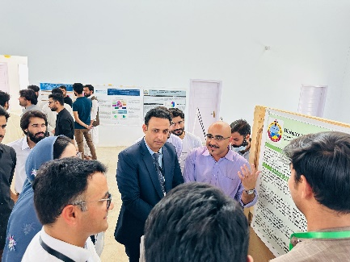 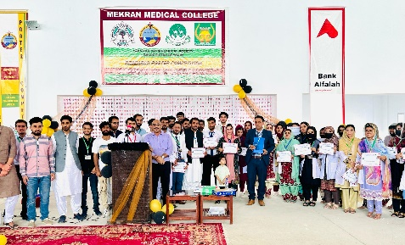 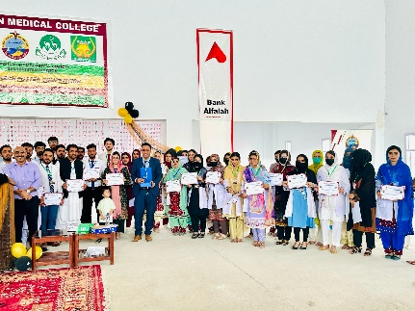

Organizing committee with students and judges evaluating the posters